**PROJECT REPORT DOCUMENTATION**

### REAL-TIME COMMUNICATION SYSTEM POWERED BY AI FOR SPECIALLY ABLED

TEAM ID- PNT2022TMID08130

**CONTENTS:-**

**1. INTRODUCTION**

1.1 Project Overview

1.2 Purpose

**2. LITERATURE SURVEY**

2.1 Existing problem

2.2 References

2.3 Problem Statement Definition

**3. IDEATION & PROPOSED SOLUTION**

3.1 Empathy Map Canvas

3.2 Ideation & Brainstorming

3.3 Proposed Solution

3.4 Problem Solution fit

**4. REQUIREMENT ANALYSIS**

4.1 Functional requirement

4.2 Non-Functional requirements

**5. PROJECT DESIGN**

5.1 Data Flow Diagrams

5.2 Solution & Technical Architecture

5.3 User Stories

**6. PROJECT PLANNING & SCHEDULING**

6.1 Sprint Planning

6.2 Sprint Estimation and Delivery Schedule

**7. CODING & SOLUTIONING (Explain the features added in the project along with code)**

7.1 User Registration and Login

7.2 Dashboard and Result

7.3 Flask integration and Deployment

7.4 Database

**8. TESTING**

8.1 Test Cases

8.2 Sample Testing

**9. RESULTS**

**10. ADVANTAGES & DISADVANTAGES**

**11. CONCLUSION**

**12. FUTURE SCOPE**

**13. APPENDIX**

GitHub & Demo Link

**1. INTRODUCTION**

**1.1 Project Overview: -**

A World Health Organization report says around 63 million

people in India suffer from either complete or partial deafness,

and of these, at least 50 lakh are children. Communication

between a deaf-mute and a normal person has always been a

challenging task. Sign language has become more widely used in

recent years, establishing effective communication between

mute/deaf people and normal people. In this tech era, people can

easily access the application, which converts sign language into

speech or text using Convolutional Neural Network(CNN). An

Alerting system is also used to notify in emergency situations.

**1.2 Purpose: -**

The main purpose of this project is to help deaf-mute people to

overcome the communication barrier by using CNN..This application

is to make deaf-mute people feel independent and confident.It will be

used in emergency situations and will also enhance their career growth

**2. LITERATURE SURVEY**

**2.1 Existing Problem:-.**

People with hearing and vocal impairment face considerable

challenges in every day life. There were some applications and devices

to help them communicate with normal people. Most of the applications

doesn’t provide two way communication options and poor lightning

results inaccurate gesture prediction.

**2.2 References :-**

| **S.NO** | **TITLE** | **PROPOSED WORK** | **TOOLS USED/ALGORITHM** | **TECHNOLOGY** | **DISADVANTAGES** |
| --- | --- | --- | --- | --- | --- |
| 1 | D-Talk: Sign  language  recognition  system for  people with  disability  using  machine  learning and  image  processing. | This application  converts sign  language into texts  and its an one way  communication**.** | Gesture  interpretation  Speech  interpretation | Machine  learning  Image  processing | Gesture interpretation  works efficiently only for  user who knows sign  language.  Poor lighting results in  inaccurate gesture  prediction. |
| 2 | Smart  Communicat  ion system  using sign  language  interpretatio  n | This application  converts the  American sign  language into text  and speech .It is a  two way  communication**.** | Media pipe  Random forest  classifier  trained on  American sign  language | Machine  learning | Computer Vision based  approach are unable to  obtain such high  accuracy on real time  data |

| 3 | Hand gesture,  and Speech  Translation  and  Recognition  System for  specially  abled people  using using  AI. | This device used to  recognize sign language  and converts them into  onscreen text as well as  audio sounds vocally  impaired. | Text to speech  algorithm. | Artificial  Intelligence | As more number of  samples are needed  so it takes more time. |
| --- | --- | --- | --- | --- | --- |

**2.3 Problem Statement Definition**

People with hearing and speech imapairment try to achive communication

with normal people but they can’t be able to get deaf-mute hand gestures this

makes the barrier in communication and in their career growth which makes

them feel indifferent from normal people. Due to their impairments they can’t

be able to call anybody for help in an emergency situations like fire accidents.

Android applications were built which will help dead-mute people to resolve communication barrier.

**3. IDEATION & PROPOSED SOLUTION**

**3.1. Empathy Map Canvas:-**

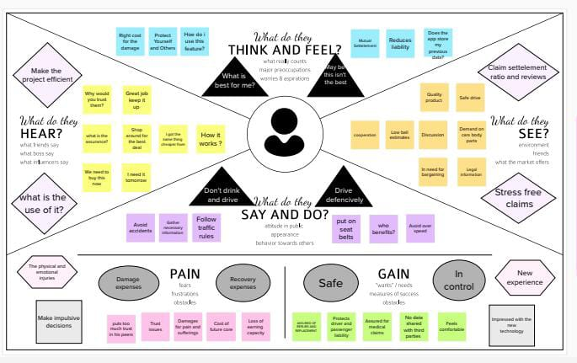

**3.2 Ideation & Brainstorming:-**

Brainstorming is an activity that will help you generate more innovative ideas. It's one of many methods of ideation the process of coming up with new ideas and it's core to the design thinking process. Brainstorming refers to a problem-solving technique used by teams or individuals.

In this process, participants generate various ideas or solutions, then begin discussing and narrowing them down to the best options. Ideation is often closely related to the practice of brainstorming, a specific technique that is utilized to generate new ideas.

A principal difference between ideation and brainstorming is that ideation is commonly more thought of as being an individual pursuit, while brainstorming is almost always a group activity.

Ideation is the process where you generate ideas and solutions through sessions such as Sketching, Prototyping, Brainstorming, Brainwriting, Worst Possible Idea, and a wealth of other ideation techniques.

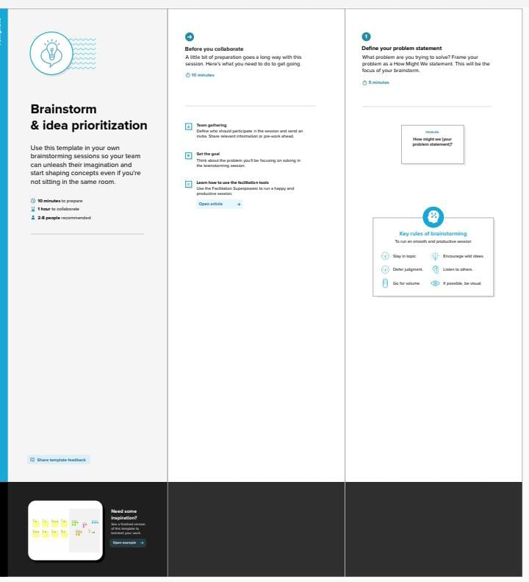

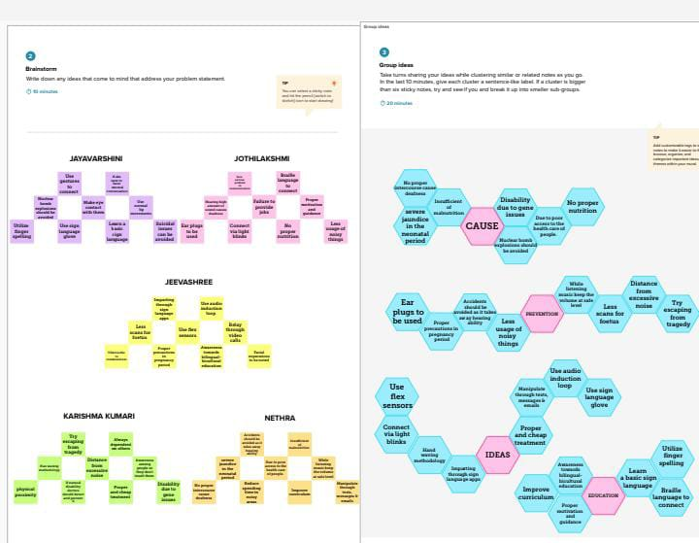

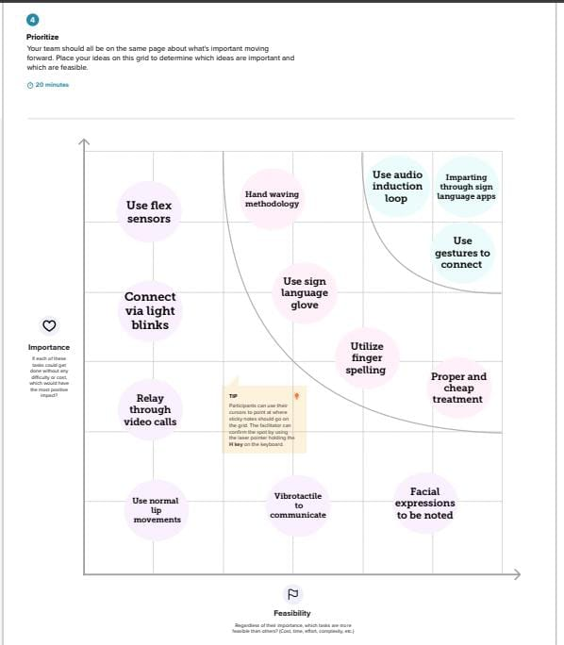

**3.3 Proposed Solution:-**

The purpose of this tool is to provide a structured process for identifying a problem, understanding the root causes, ascertaining solution steps, and progress monitoring. With a solution template, you can organize development content that you want to reuse for customer-specific solutions.

Solution templates enable you to easily start the development of customer-specific solutions, for example, for a specific industry. The term business model refers to a company's plan for making a profit. It identifies the products or services the business plans to sell, its identified target market, and any anticipated expenses. Business models are important for both new and established businesses.

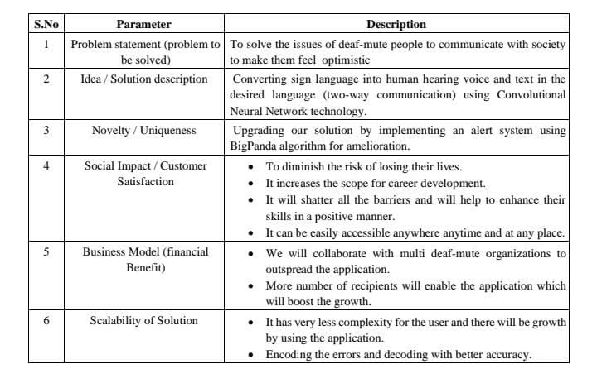

**3.4 Problem Solution Fit:-**

The Problem-Solution Fit simply means that you have found a problem with your customer and that the solution you have realized for it actually solves the customer's problem.

Problem-Solution Fit - this occurs when you have evidence that customers care about certain jobs, pains, and gains. At this stage you've proved the existence of a problem and have designed a value proposition that addresses your customers' jobs, pains and gains.

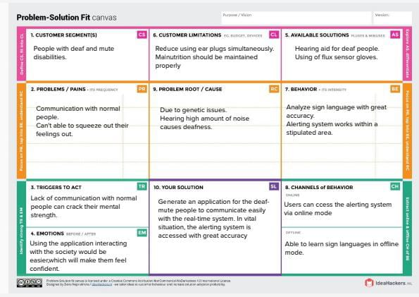

**4. REQUIREMENT ANALYSIS**

**4.1 Functional Requirements:**

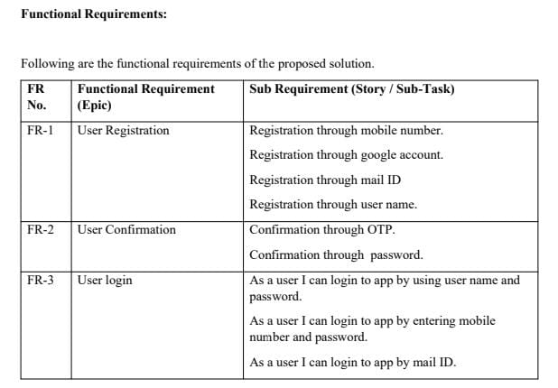

**4.2 Non- Functional Requirements:-**

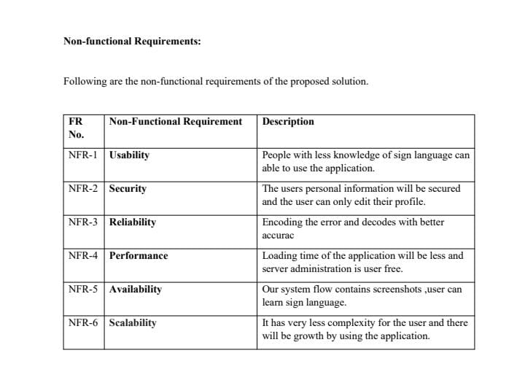

**5. PROJECT DESIGN**

**5.1 Data Flow Diagrams:-**

A Data Flow Diagram (DFD) is a traditional visual representation of the information flows within a system. A neat and clear DFD can depict the right amount of the system requirement graphically. It shows how data enters and leaves the system, what changes the information, and where data is stored.

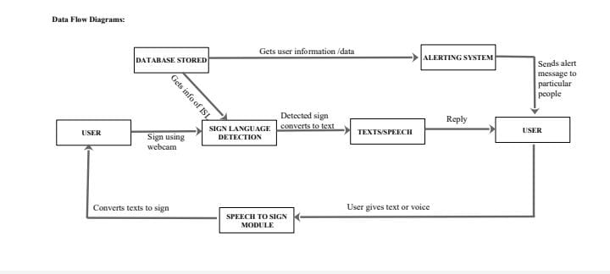

**4.2 Solution & Technical Architecture: -**

**Solution Architecture:**

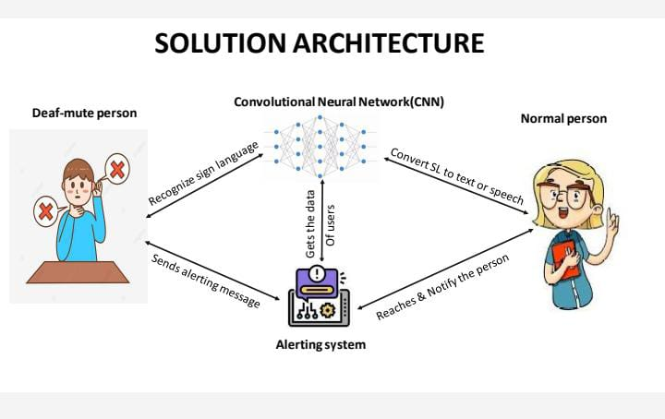

**Technical Architecture:**